# **Overview and Statistics of Surrounding Businesses**

**________________________________________________________________________________________________________**

Location: Albany, New York

County: Albany_County

Radius: ~6.22 miles

Business type: Cafe

Number of businesses found: 38

To track minimum wage for your state: https://www.epi.org/minimum-wage-tracker/#/min_wage/New%20York

**________________________________________________________________________________________________________**

**Map**

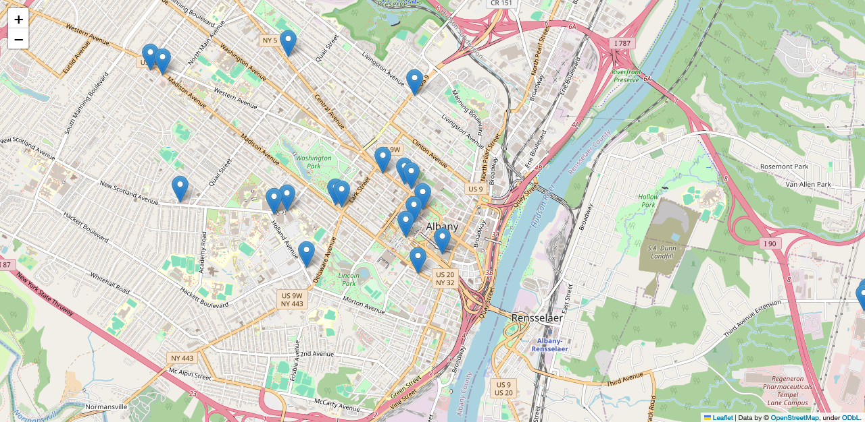

**________________________________________________________________________________________________________**

**Hours**

*Places that are open the most (in hours)*

|  |  |
| --- | --- |
| Stewart's Shops (204 Henry Johnson Blvd, Albany, NY 12210) | 126 |
| Stewart's Shops (285 New Scotland Ave, Albany, NY 12208) | 126 |
| Stewart's Shops (19 Fuller Rd, Albany, NY 12205) | 126 |
| McDonald's (106 Wolf Rd, Albany, NY 12205) | 119 |
| Starbucks (Hilton Garden Inn at Albany Medical Ctr, 62 New Scotland Ave, Albany, NY 12208) | 116 |

*Places that are open the least (in hours)*

|  |  |
| --- | --- |
| Hill Street Cafe (180 Madison Ave, Albany, NY 12202) | -47 |
| Cumberland Farms (430 Rte 9W, Glenmont, NY 12077) | -35 |
| McDonald's (1006 Central Ave, Albany, NY 12205) | -7 |
| PRIME at the Plaza (1, Empire State Plaza, Albany, NY 12210) | 30 |
| Better Bite (99 Washington Ave, Albany, NY 12210) | 30 |

*Average hours open per week*

|  |  |
| --- | --- |
| Average Hours Open | 80.41 |
| Average Hours Per Day | 11.49 |

*Days that places are closed the most*

|  |  |  |
| --- | --- | --- |
| Sunday | 5 | Cafe One Eleven (111 Washington Ave, Albany, NY 12210), El Loco Mexican Cafe (465 Madison Ave, Albany, NY 12210), Dunkin' (Capital Bldg, 170 State St Nys, Albany, NY 12207), PRIME at the Plaza (1, Empire State Plaza, Albany, NY 12210), Better Bite (99 Washington Ave, Albany, NY 12210) |
| Monday | 1 | El Loco Mexican Cafe (465 Madison Ave, Albany, NY 12210) |
| Tuesday | 1 | Iron Gate Cafe (182 Washington Ave, Albany, NY 12210) |
| Saturday | 4 | Cafe One Eleven (111 Washington Ave, Albany, NY 12210), Dunkin' (Capital Bldg, 170 State St Nys, Albany, NY 12207), PRIME at the Plaza (1, Empire State Plaza, Albany, NY 12210), Better Bite (99 Washington Ave, Albany, NY 12210) |

*Earliest open places*

|  |  |
| --- | --- |
| Dunkin' (1040 Central Ave, Albany, NY 12205) | 04:00 AM |
| Dunkin' (557 Columbia Turnpike, East Greenbush, NY 12061) | 04:00 AM |
| Cafe Madison (1100 Madison Ave, Albany, NY 12208) | 04:00 PM |
| Stewart's Shops (285 New Scotland Ave, Albany, NY 12208) | 04:30 AM |
| Stewart's Shops (19 Fuller Rd, Albany, NY 12205) | 04:30 AM |

*Latest open places*

|  |  |
| --- | --- |
| Cumberland Farms (430 Rte 9W, Glenmont, NY 12077) | 12:00 AM |
| Cafe Madison (1100 Madison Ave, Albany, NY 12208) | 11:00 PM |
| McDonald's (106 Wolf Rd, Albany, NY 12205) | 11:00 PM |
| Stewart's Shops (204 Henry Johnson Blvd, Albany, NY 12210) | 11:00 PM |
| Stewart's Shops (285 New Scotland Ave, Albany, NY 12208) | 11:00 PM |

*24/7 places*

* McDonald's (31 Holland Ave, Albany, NY 12209)

**________________________________________________________________________________________________________**

**Ratings:**

*-Average Rating of 38 Businesses:*

* 3.99 stars

*-Bad Ratings and Examples (1-2 stars):*

* I’m always in a great mood. Always!!  
  I enjoy the produce sold at honest weight but for some reason this Very rude older woman seemed to get under my skin as opposed to the lady who greeted me at customer service.  
  I get it, not everyone is a morning person. Maybe they can schedule her later in the day after she stables her attitude  
  I will make it my business to use self service for now on and never have a conversation with any employee. I feel the culture should be more pleasant and comfortable and compassionate with all worker And customers alike  
  It’s not that serious you’re a cashier and my effort to spread joy will be limited. Thanks see you next visit 🤔
* Worst customer service I have ever experienced. The manager Refused to open gate to mall for 7 month pregnant woman who was parked on other side of the mall with no announcements or warnings of closing the back gate. It was just 2 minutes past six o’clock. And not only was our sale refused when the store was open but there was no warning when we walked in through the mall entrance just before 6pm that they would be closing the mall entrance to the store. Absolutely unacceptable. There was also an elderly man as well as another lady who heard no announcements yet were forced to walk around the front of the building in 92 degree weather to get back into the mall to get to where they parked. Utterly disgusting.
* The employees here can't be bothered to put aside a personal conversation to pay attention to the customers they are cashing out. It's a gas station, I'm not expecting top tier customer service but it's a pretty bad experience to not even be acknowledged by the cashier. At least a kiosk says thank you.
* I go to Starbucks every morning as I’m sure many people do. I have had to go out of my way to go to this store because the other Starbucks on my route to work is never in stock and generally I cannot order ahead.  
  This morning I preordered a venti (very basic) drink and egg bites about 15 minutes before I would be reaching the store. My drink was done but not the egg bites. After waiting about 15 minutes my food was still not ready and the employees did not seem to have any care. I ended up walking out without my food so I would not be late for work. The food is made in a microwave people…
* I rarely go to starbucks because dunkin is cheaper, you get more for your money. My fiance and i decided to splurge and get drinks and 2 sausage bacon and egg wraps. The frappuccino i got had tons of whipped cream in the bottom and top so i got virtually no drink. The wraps were comprised of egg and potato with a single half piece of bacon and 1 small nickel sized bite of sausage at the bottom of the wrap(this was the case for both wraps). My fiances grande pink drink was absolutely full of ice with probably a 1/2 cup of actual drink. So disappointing.. we are charged so much for these items but we really dont get what we pay for.

*-Good Ratings and Examples (4-5 stars):*

* Very impressed with all the Organic selections here and the knowledge of most if not all of the folks working here! I will Definitely be coming back as often as I'm here in the area and Highly recommend shopping here if you buy healthy foods and drinks! I was also Very impressed with the Kombucha on tap and all the flavors, WOW, Fantastic! 😁👍🏼👍🏼👍🏼
* Home to hard to find Vegan specials in the Albany, New York metro area. My Bacon is manufactured in Green Island, New York and is sold at Honest Weight Food Co-op. Which also has several vegan cheeses and frozen vegan products. I have been a customer since the early 2000's and shop there at least twice a week. Still not a member yet. But this is one of the places I frequent to purchase my groceries. The staff are very friendly and informative on the products sold. I must add they care about the freshness of what they carry and serve.  
  Was there on January 31, 2024 to purchase some items for my Wife, ( SHE LOVES THE HUMMUS WRAPS AND SEVERAL OTHER ITEMS, I cannot come home empty handed 🤣 ) there were a few items that were on the shelf with an expiration date of today January 31, 2024, I asked the staff in the deli if I can ask for a fresher one to be made and the gentleman in the deli made a few new ones, so I ended up purchasing 2 Hummus wraps, which I will say are very delicious 👍. I enjoy shopping at Honest Weight because of the VERY POSITIVE CUSTOMER SERVICE INTERACTION 👍👍👍👍👍
* The freshest, best tasting packaged meat and chicken at any store in the area. Love the Field Day line for organic items. Love the specialty/international section. Also love the monthly contributions to different charities. Agree with some other reviewers that some of the volunteers/staff working there can be unnecessarily patronizing and unfriendly. However, most volunteers/staff there are very helpful and friendly. It would be helpful to allow a higher number of items through self check out, especially if it’s not busy. I prefer self check out and find myself limiting what I buy so I can go through that line. Thanks for providing our community with clean food!
* Great co-op. Bulk section is my favorite. Coffee selections are top notch. Fish and meat you can trust. Plants and seeds for your garden. A very pleasant, calm experience every time I visit!
* Reasonably priced, super friendly service and great menu! I wish I found this place sooner. A great option for lunch near me. Salads, sandwiches, burgers, breakfast options, and cold brew.  
    
  Plus you can see the whole grill and it is exceptionally clean, the food is made to order.

**________________________________________________________________________________________________________**

**What Businesses in the Area Serve**

*Proportion of what Businesses Offer*

|  |  |
| --- | --- |
| Serves breakfast | 78.95% |
| Serves lunch | 78.95% |
| Serves brunch | 57.89% |
| Serves dinner | 55.26% |
| Serves wine | 15.79% |
| Serves beer | 15.79% |
| Wheelchair accessible | 94.74% |
| Serves vegetarian | 55.26% |
| Dine in | 84.21% |
| Takeout | 94.74% |
| Reservable | 7.89% |
| Average price level (out of 4) | 1.5 |

*Suggestions to Offer*

Less than 50% of businesses have these available:

* Wine
* Beer
* Reservable

**________________________________________________________________________________________________________**

**Demographics Data**

*Data from United States Census Bureau reflects available data*

*Race*

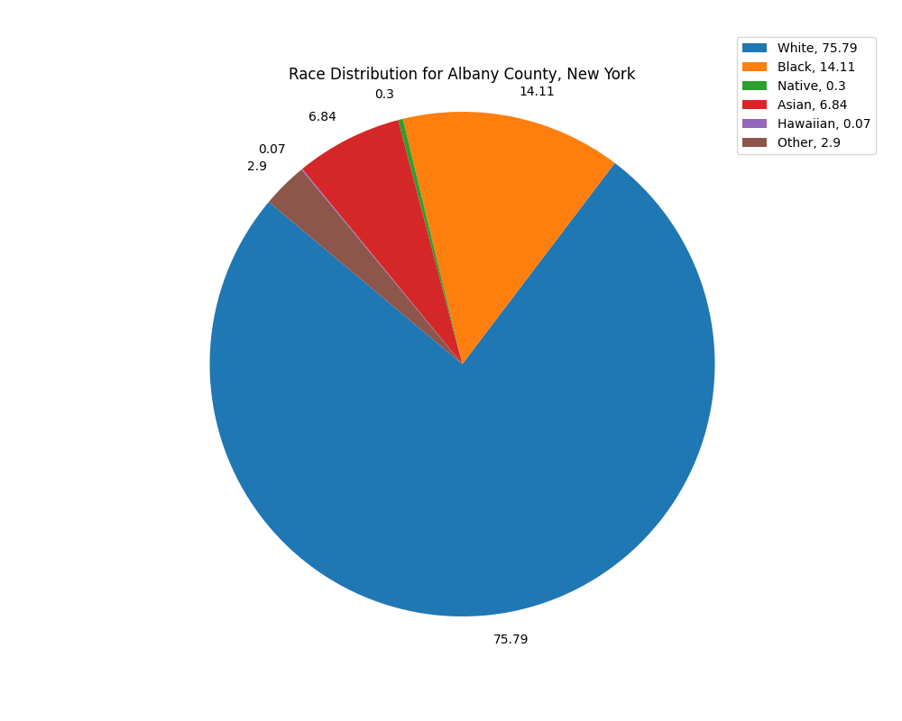

*Age*

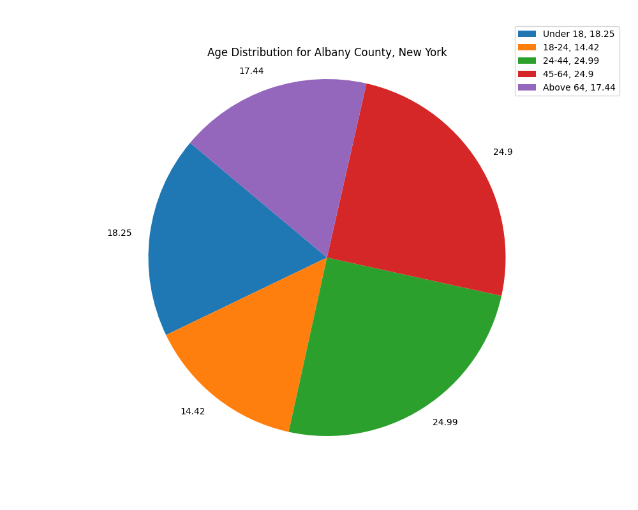

*Sex*

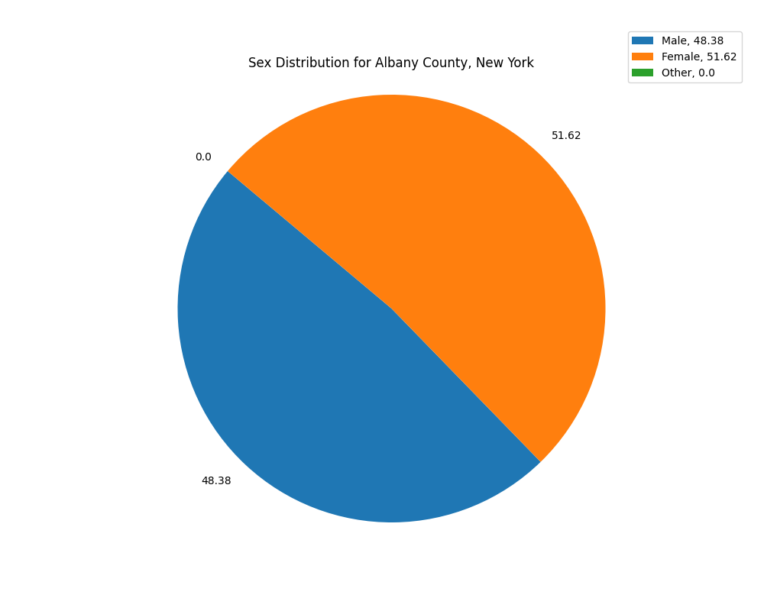

**________________________________________________________________________________________________________**

**Migration Trends**

*Data from United States Census Bureau reflects available data between 2010-2021*



